User's Manual

SAFETY INSTRUCTIONS
- Make sure your battery has enough voltage for the controller to recognize the battery type before first installation.
- The battery cable should be as short as possible to minimize loss. 3.The regulator is only suitable for lead acid batteries:OPENA,GM ,GEL
It Is not suited for nickel metal hydride,lithium ions or other batteries .
4.The charge regulator Is only suitable for regulating solar modules. Never connect another charging source to the charge regulator.

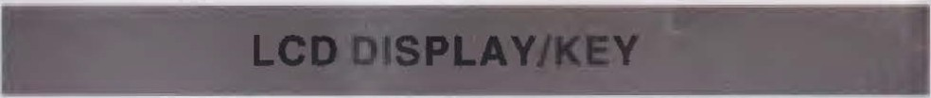
The battery voltage or allghtdelaycloslng- time display

Solar Input Indication - Charging Instructions:
LOADOHB B B B cv
;;
G)
C.
j j I
®
llmhlog who,o ho<glog, often bright full or constant
voltage charging Battery power Indicator
Load indication

MENU UP
T/<J DOWN/
ON/OFF

Nota: 1, the light control function la controlled by the solar panel, the use of llght control function must access the solar panel, otherwise the light had no effact.
2.Load symbol I -,, ) Light, only that the load output has been turned on, and there is no connection to the load.

As long as It Is not set to (1•15H) Or (OH) model,(The optical delay model ),Battery not under pressure condltlon(Battery symbol does not blink ),Single short press the turn key can open /Close load output•

MENU:switch between different display.or to enter/exit setting ty
-

TROUBLE SHOOTING
Situation | Probable causi | Solution
Charge Icon not on when sunny | Solar panel opene1 or reversed | Reconnect
Load Icon off | Mode setting wron1 | Set aaaln
 | Battery low | Recharge
Load icon slow flashing | Over load | Reduce load watt
 | Short circuit prolectlon | Remove short circuit, 1 minutes or so automatic recovery
Power off | Battery too low/  reverse | Check battery/connection

long press.
UP:press to Increase value. DOWN:pre ss to decrease value.
PRODUCT FEATURES

- Bulld•ln Industrial micro controller,
- Large-screen LCD display, charging and discharging current display, cumulative power generation and discharge power query, temperature display, light control+ delay control; adjustable charge and discharge parameters, with power-off memory and other functlona.
- Dual USB output, the maximum current of 2.5A, to support Apple's
mobile phone charging.
r
- Fully 3-stage charge management.
- Bulld·ln short-ciccuit protectlon,open-clrcult protectlon,reverse protect1on,over-1oad pro ec on.
- Reverse current protectlon,low heat production.
-

1 SYSTEM CONNECTION
- - - ,r -

1.connect the battery to the charge regulator-plus and minus. 2.Connect the photovoltaic module to the regulator-plus and minus. 3.Connect the consumer to the charge regulator-plus and minus.
-

DISPLAY/SEETING

Battery Voltage Solar Panel Load
(main Interface) charge current discharge current
PYOff I "!."Iv
*I
I
W<.J
High Voltage Diaconneftion(HVD)
-
-
;-'
LOAD 2 108 Ah -
l
Accumulated Accumulated Discharging power(Ah) charging power(Ah

--­
Low voltage Reconnectlon(LVR)
Low Voltage Dlsconnectlon(LVD)
Load working Mode
PY 2168 Ah
*#'r;;i.i-i::
W<.J
8.3 A
;-'
LOAD
.J.111
IU.U A
PY
* I
rnn
12.0v
*I IJ.W, t

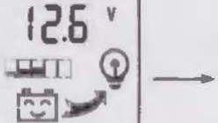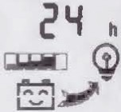)
LOADOlt
LOAD ON
LOAD
on
10.1v
o:r:c
,0'

TECHNICAL PARAMETER

The reverse order applies when deinstallingl
An improper sequence order can damage the controllerI

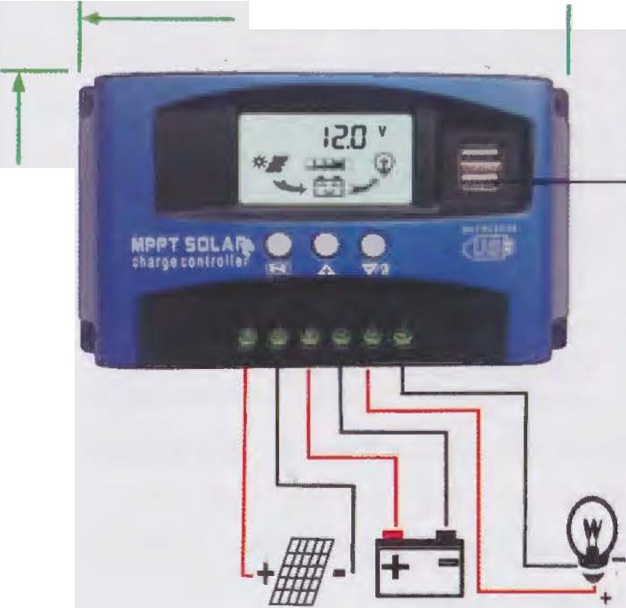
168mm----.
E
E
II)
L
0,

□•••
•••

•••

Operation instructions :
- ahort pre11 menu key to cycle through the Interface and parameters;
- long press the menu button for 3S to entar the aattlnga manually, this number will be fleshing, Into the corresponding aet profect on turn, turn key adfustment parameters you want value, after the completion of the system of automatic memory setting value and exit eetup menu;
Function declaration:
1, discharge recovery voltage: refers to the battery discharge.protection, the battery voltage to restore voltage , open the output;
- the discharge cut-off voltage: refers to the battery discharge to thevoltage
when the load off, to protect the battery , to prevent the battery over dlacharge damage.
- load operation mode:
(24H) Load output 24Hours (except for battery under voltage)
(1-15H) Load on after sunset and closed after setting hours (OH) Dusk to dawn
( XW-LCD00l -8)

- All red co lor voltage x2.whlle using 24V system
MODEL | BL912A I BL912B IBL912C IBL912DI BL912E
Batt voltage | 12V/24V auto
Charge current | 20A I 30A I 40A I S0A I 60A  I
Discharge  current | 10A 10A I 20A I 20A I 30A
Max solar input | 12V battery, the hl est 23V;  24V battery when e hiahest 46V
Equalization | 14. 4V
Float charge | 13.7V l defaul,adjustable l
Discharge stop | 10.7V (defaul ,adjustab te l
Discharge | 12.6V(defaul,adjustable)
Charge reconnect | 13V
Voltage of open light | Solar panel 8V(Ll ght lights delay)
Voltage of close light | Solar panel SV (Ll ght off delavl
USB output | 2 way use output, SV/2.SA(MAX)
Self-consume | <10mA
Operating temperature | -35~+60C
Size/Weight | 170 • 92 • 45mm / 450g

*This Instruction Is a general manual, such as a sllght difference In the physical.
•Product specifications ore subject to change without prior notice

