MULTIHULLS
All the benefits of a HYDROVANE can be enjoyed by a cruising multihull (not high speed performance boats – speeds over 10-12 knots can cause limitations):
- Ease of use
- Competent in all conditions (subject to speed limitations)
- Complete back-up steering system
- Enormous reliability
MODERN PERFORMANCE CATS – The newer, lighter and larger cats can have performance issues:
- Rapid acceleration & decceleration – constantly changing ‘boat balance’ in regards to course to the apparent wind – changes in apparent wind direction requires a Hydrovane course adjustment …… well, some tweaking of the course setting line
- Weak apparent wind – There is an ideal reaching condition in lighter airs when the boat can move as fast as the wind is blowing but leaving little apparent wind to power the Hydrovane.
- High Superstructure – need to get the vane as high as possible – to reach above the cabin top where the good wind is
- Leeway – Depending on the relative weight of the boats and the amount of keel structure, some multihulls have considerable ‘leeway’ or sideways drift – results in ‘dirty water’ for the Hydrovane. Dirty water refers to the flow of water on the Hydrovane rudder – must be in the normal fore and aft direction – parallel to the centerline of the boat.
OFFSET INSTALLATIONS – Reports of offset installations are mixed – again the older heavier boats have no problems. The issue, we believe, is ‘dirty water’ caused by either the wake from the nearby hull or leeway. Our conclusion is more tempered on the offset – recommend amidships location for all ‘modern’ cats.
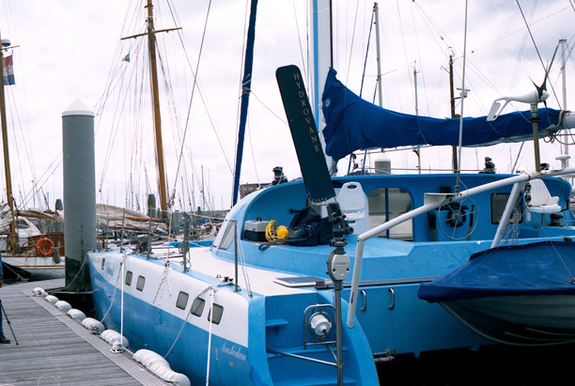
Lexline 49 – Dutch Catamaran – “Hydrovane performed way beyond expectations!”
BACK-UP RUDDER – Perhaps mutihulls have even more vulnerability to rudder failure than monohulls because their rudders are unprotected and unsupported – usually simple spade rudders lacking a protective keel or anything like a skeg or bottom support – even if well built, not nearly as strong as Hydrovane’s solid nylon rudder. Hence having a separate independent rudder and steering system should be of enormous value.
___________________________________________________________

