boats and equipment saint-petersburg, russia

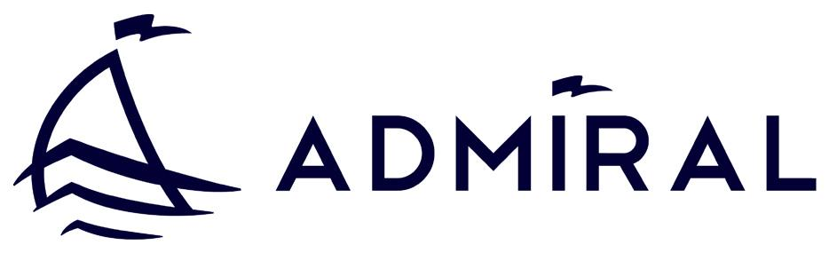

one of the largest manufacturers of inflatable boats in CIS countries

with production site located in Saint Petersburg, Russia. ADMIRAL is fast developing and export oriented Russian company.

N’hésitez pas à nous contactez pour toutes demandes.

Truffimpex Ltd
Mr Tricoire Thierry
truffimpex@hotmail.fr
Tel : + 359/893 745 632
production and sales volume 03

 |  |  |  |  |  |  |  | 19000
total sales
export sales |  |  |  |  |  |  | 16000
 |  |  |  |  |  | 13500
 |  |  |  |  | 10000
 |  |  | 4200 | 5500
 |  | 3500
1200 | 2000
2009 | 2010 | 2011 | 2012 | 2013 | 2014 | 2015 | 2016 | 2017
 |  |  |  |  |  | plan | plan | plan
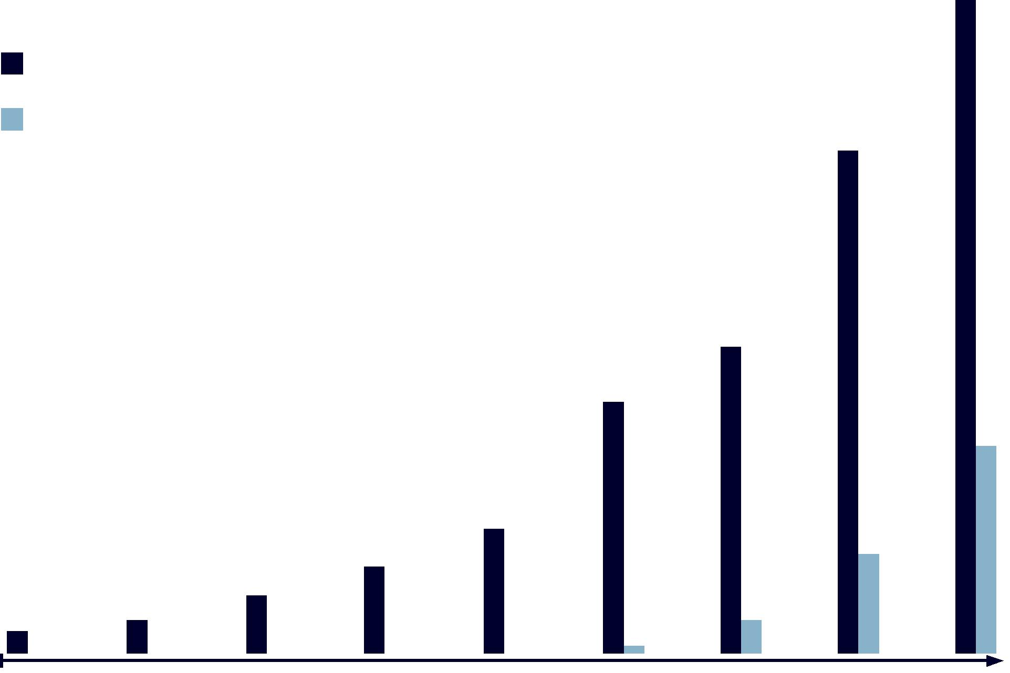

sales geography 04

CURRENT SALES:

Russia, Finland, Turkey, UAE, Croatia, Belorussia, Kazakhstan

EXPANSION PLANS:

USA, Canada, Germany, Sweden, Bulgaria, Greece, Belgium, Spain, France, Italy, Romania, Check Republic, Netherlands.
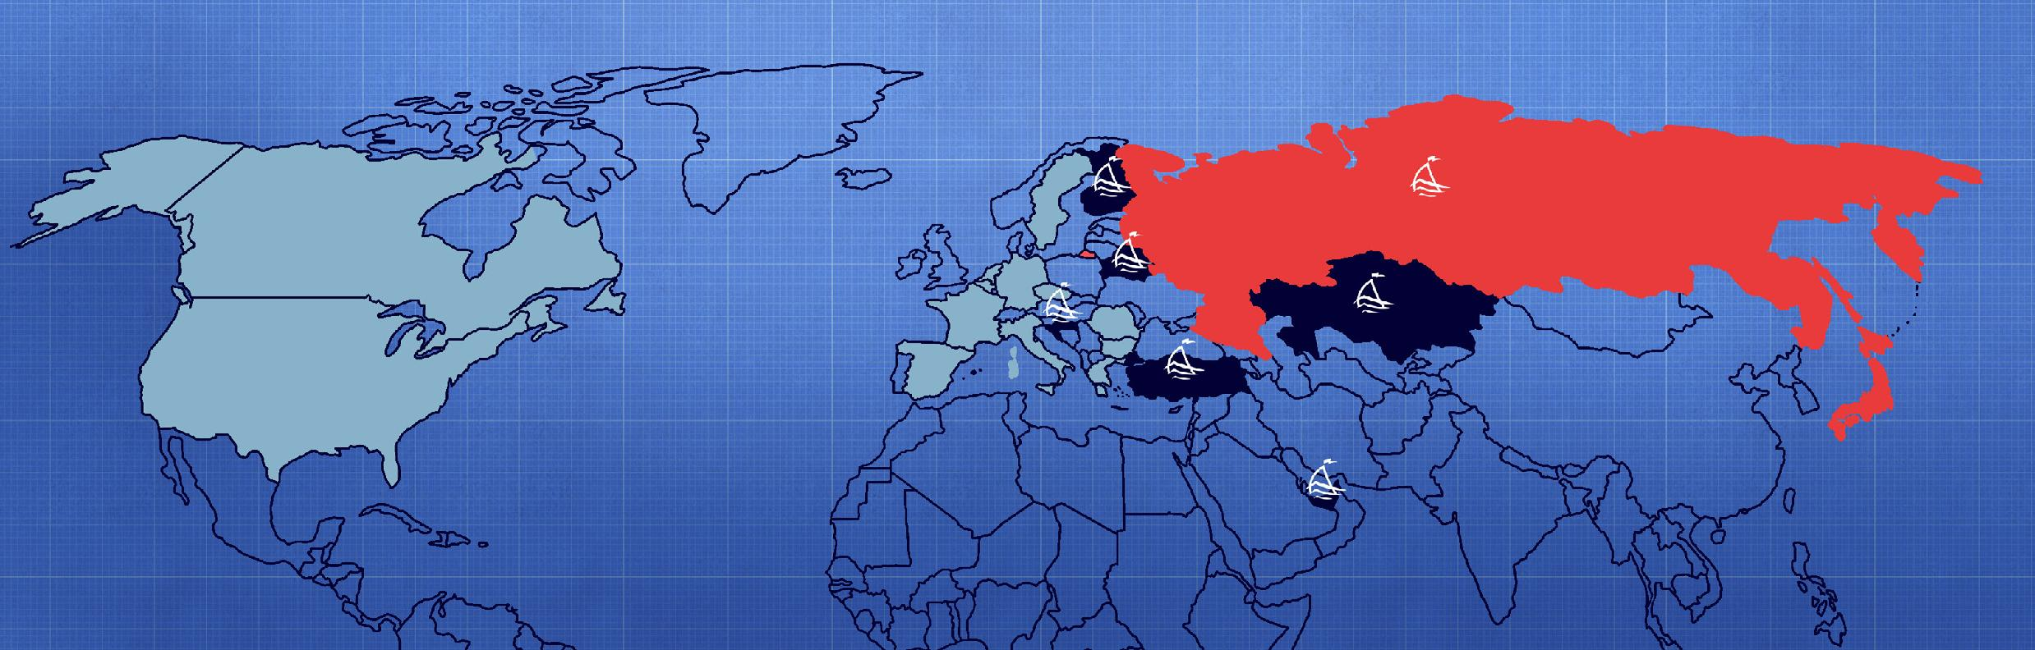

inflatable Boats and their advantages

inflatable Boats and their advantages 06
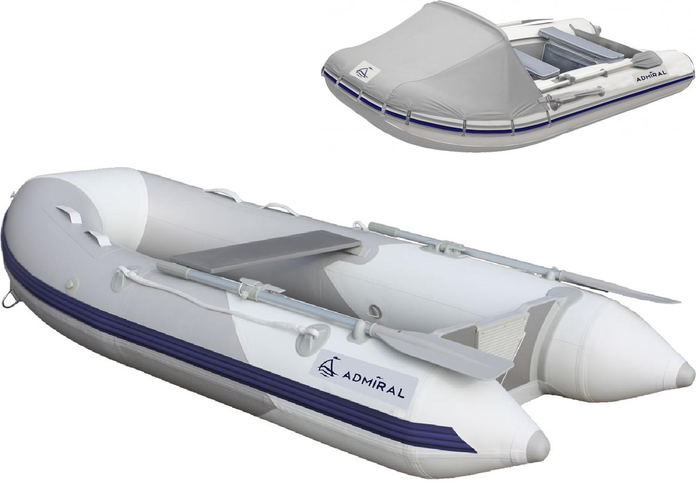

What’s inflatable boat?

An inflatable boat is a lightweight boat constructed with its sides and bow made of flexible tubes containing pressurised gas. For smaller boats, the floor and hull is often flexible, while for boats longer than 3 metres, the floor typically consists of three to five rigid plywood or aluminium sheets fixed between the tubes with rigid transom for outbourd motor.

inflatable Boats and their advantages 07

Conventional boats inflatable boats

1. Safety less more

2. Stability less more

3. floatability less more

inflatable Boats and their advantages
08

    - load capacity

- boat weight

  - storage space and transportation

    - price

Conventional boats

less
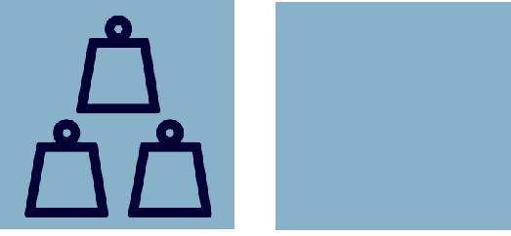

more
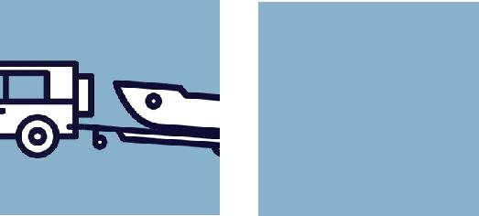

more

more

inflatable boats
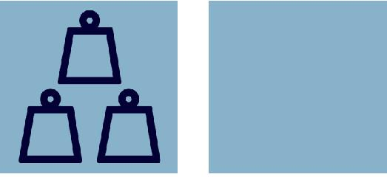

more

less

less

less

boats thechnology

boats thechnology 10

The Admiral motorboats combine modern technologies and years of experience of designers.
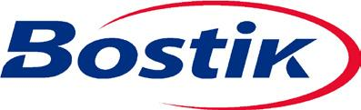

Top coat Primary coat
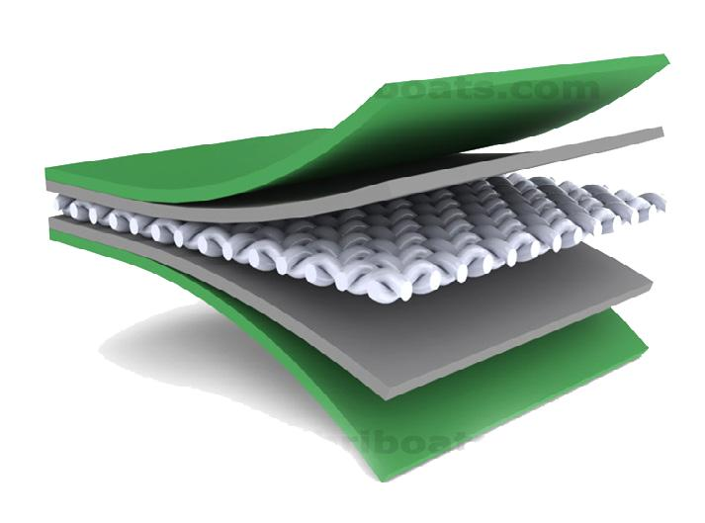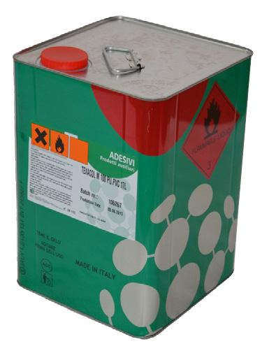
Base fabric

Primary coat

Top coat

Marine grade plywood
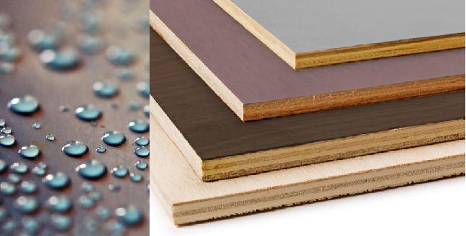

Plasticizing agents make an elastic material, which is important for folding and unfolding the boat, especially at low temperatures. The material is resistant to ultraviolet radiation, salt water, fuels and oils. It retains its properties in the

temperature range from -30 В° C to 60 В °C.

To glue seams we use adhesive with polyuretane base, which consists of 2 components resistant to ultraviolet.

For the floor, seats and transom we use specifically engineered for boats and yachts laminated waterproof plywood from Finland manufacturer.

boats thechnology 11
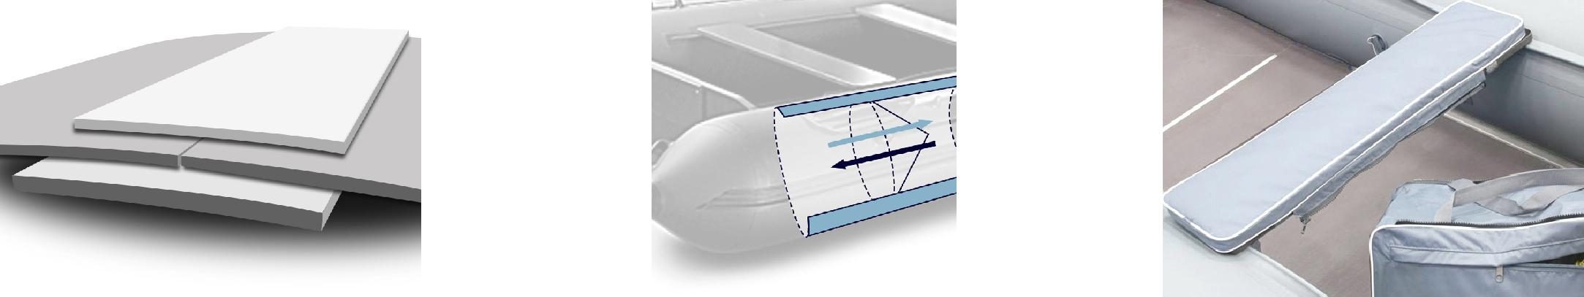

Seams joint Separate air chambers Movable seats

Boats benefits and advantages 12

OUR TECHNICAL ADVANTAGES

easy sliding (higher speed) easy and fast planning mode
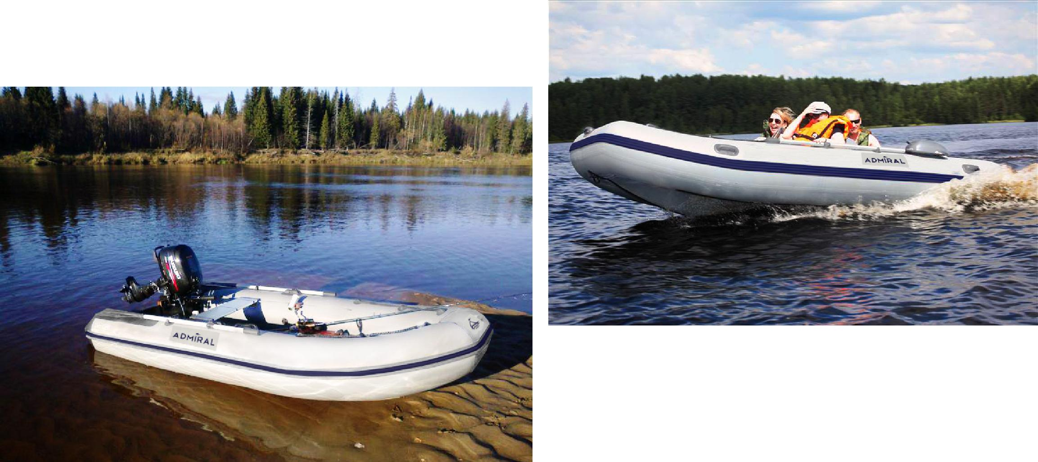

directional stability durable use

admiral boat models

admiral boat models 14

rowboats | motor-rowing boats:
 | superior seaworthy
am-280/am-300
am-280p/am-300p | am-380/am-410
am-28t0/am-300t | am-430/am-450
am-28pt0/am-300pt | am-480/am-500/am-520
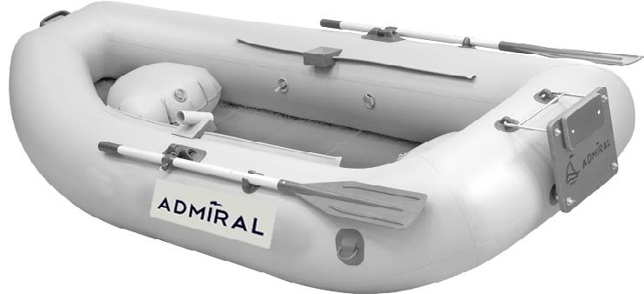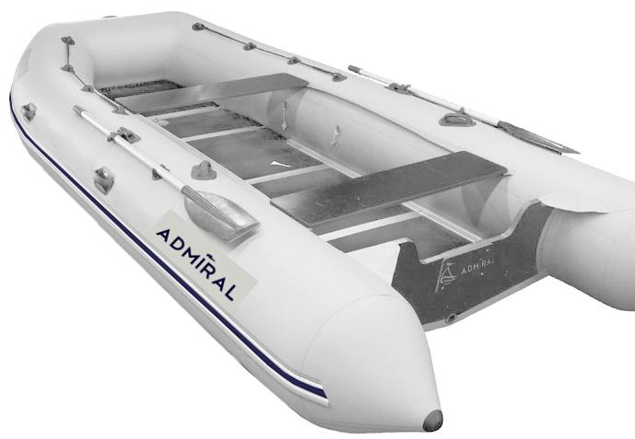

«classic» series

am-305cl/am-320cl am-305c am-320c
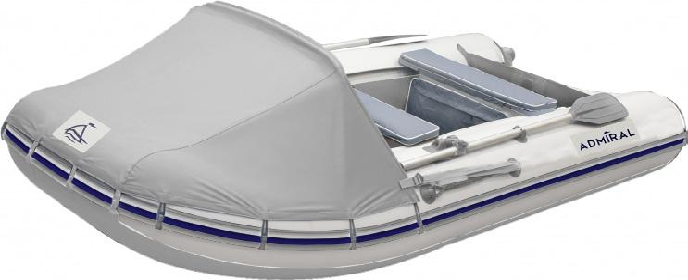

motor-rowing boats: | «sport» series
seaworthy
 | am-320s
am-380/am-410 | am-340s/am-360s
am-430/am-450 | am-340sl
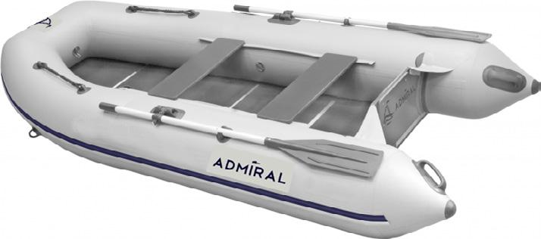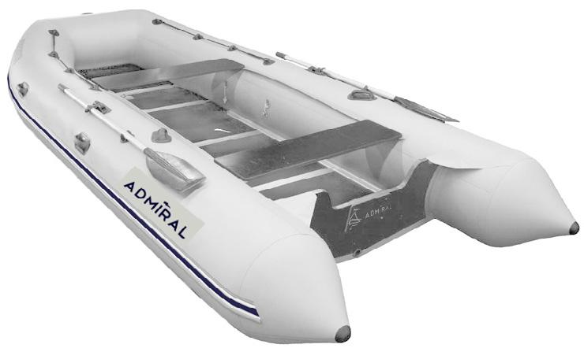

Admiral business Advantages

Boats benefits and advantages 16

why Admiral?

Customer oriented Custom design
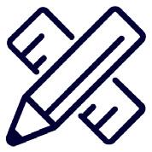

Highest quality standards (CE)
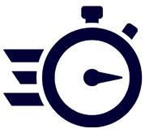
Geographical proximity (cheap and easy logistics)
Hand work

Top grade materials

Flexible price policy

thank you for your attention

visit us – admiralboat.com
Contact for France :

truffimpex@hotmail.fr

Mr TRICOIRE THIERRY
Tel : +359/893745632

