Know how: Wind Generators
Sam Fortescue
Nov 17, 2017
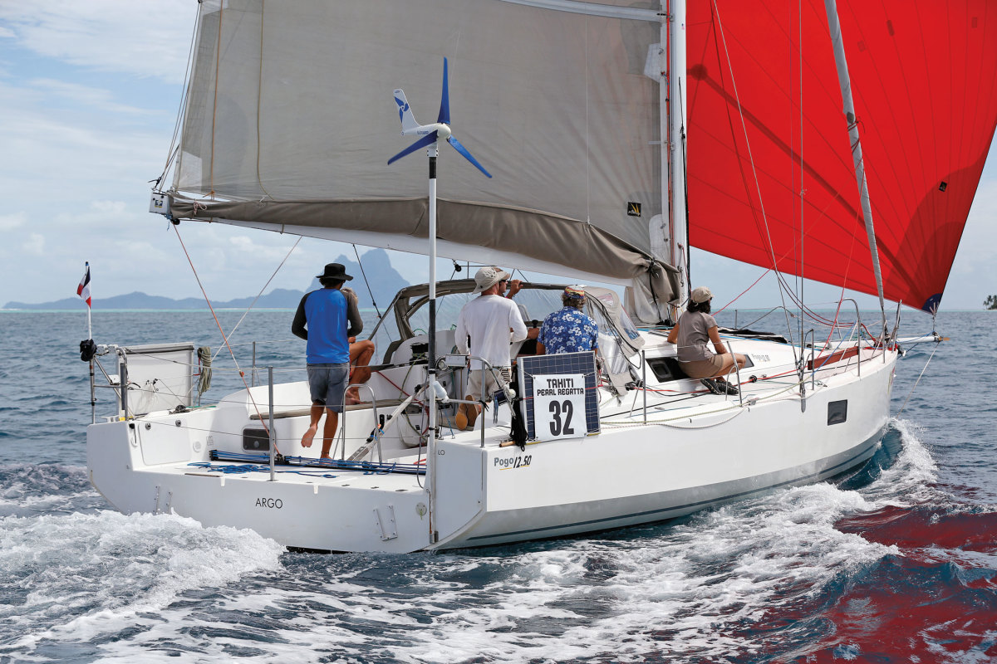
Wind generators aren’t at their best off the wind
Photo by Graham Snook
Wind generators have a natural appeal to sailors in need of extra power. They harness the same element that we rely on to get from A to B, and the technology behind them is well proven and reliable. Despite the growing popularity of hydrogenerators and ever more efficient solar panels, wind generators are still a common sight on bluewater cruising routes.
At the outset, it’s important to note the advantages and limitations of wind power for keeping the batteries charged. On the plus side, the generator will keep pumping out power at anchor or in port, as well as on cloudy days. It is also largely maintenance-free and requires no launch or recovery. These can be powerful units, churning out 400 watts of power or more—enough to charge 800 amp hours (Ah) of battery capacity per day on a 12-volt system.
On the downside, the world’s cruising routes tend to be downwind, robbing the generator of some of its power. In fact, the relationship between wind speed and the energy it contains is cubic, so power decreases exponentially. To put that in context, a boat doing 8 knots dead downwind in 20 knots of true wind would experience an apparent wind of just 12 knots. A turbine might generate 40 watts in 12 knots of wind, but most manage 200 watts in 20 knots. Furthermore, ports and anchorages appeal to sailors precisely because they offer protection from the elements, so wind speeds will be lower than forecast offshore.
In addition, these days, solar panels have more or less eclipsed small wind turbines for trickle-charging batteries when you’re away from the boat. (Although, there are still some small turbines available, such as the Rutland 504, which tops out at 5 amps on a 12-volt system.) So, chances are that if you’re looking to install a wind turbine, you’re looking to install a more powerful model alongside solar panels or a hydrogenerator.
Almost all the turbines listed below claim outputs of 400 watts or more—the D400 claims in excess of 600 watts. Of more interest, however, is the output at the lower wind speeds that most of us typically encounter (or plan to encounter) during a cruise. Performance in 12 knots or 20 knots of apparent wind is a much better indication of charging potential. For example, if you’re heading to the Caribbean and plan on beating into 20 knot tradewinds every day, you’ll get much better output than, say, summer cruising in Maine.
Also, don’t forget that the power curves quoted by the manufacturers are usually based on results from smooth, constant airflow in a wind tunnel. Real-world results can be rather lower. That’s why some cruisers with heavy power requirements opt to install two turbines, and most are designed to be easily connected in parallel through a single regulator.
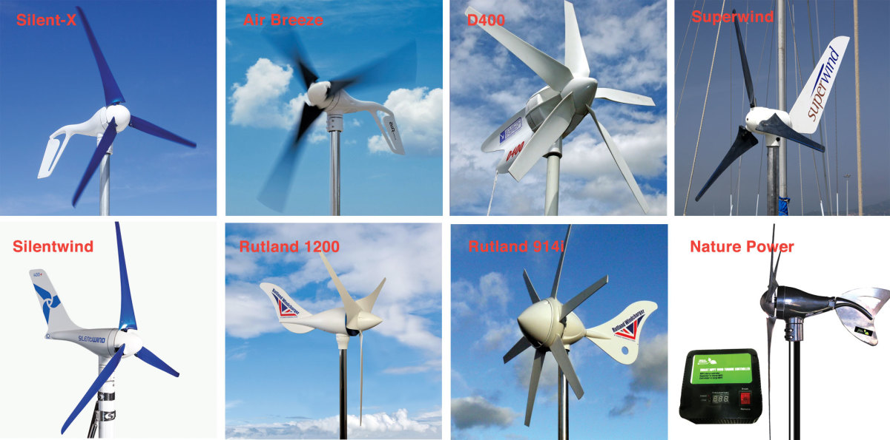
 | Turbine |  |  |  |  |  |  |  |  |  |  | Silent-X | Air Breeze | D400 | Superwind | Silentwind | Rutland 1200 | Rutland 914i | Nature Power
 | Max power (W @ 12V) |  |  |  |  |  |  |  |  |  |  | 450 | 250 | 600 | 350 | 420 | 483 | 450 | 400
 | Wind @ max (kt) |  |  |  |  |  |  |  |  |  |  | 25 | 22 | 37 | 24 | 28 | 29 | 39 | 24
 | 20kt output (W) |  |  |  |  |  |  |  |  |  |  | 200 | 230 | 192 | 180 | 140 | 255 | 135 | 280
 | 12kt output (W) |  |  |  |  |  |  |  |  |  |  | 40 | 50 | 48 | 20 | 45 | 60 | 40 | 55
 | Cut-in speed (kt) |  |  |  |  |  |  |  |  |  |  | 6,0 | 6,0 | 5,0 | 6,8 | 4,2 | 4,0 | 5,8 | 6,1
 | Voltage |  |  |  |  |  |  |  |  |  |  | 12, 24, 48 | 12, 24, 48 | 12, 24, 48, 72 | 12, 24 | 12, 24, 48 | 12, 24 | 12, 24 | 12, 24
 | Weight (lb) |  |  |  |  |  |  |  |  |  |  | 13 | 13 | 38 | 25 | 15 | 17.2 | 25.5 | 12.3
 | Diameter (in) |  |  |  |  |  |  |  |  |  |  | 46 | 46 | 43 | 47 | 45 | 48 | 36 | 47
 | Blades (nr) |  |  |  |  |  |  |  |  |  |  | 3 | 3 | 5 | 3 | 3 | 3 | 6 | 3
 | Tip speed ratio (TSR) |  |  |  |  |  |  |  |  |  |  | 8.5 | 6.4 | 3.9 | 6.5 |  | 7 | 3.5 | n/a
 | Regulation included |  |  |  |  |  |  |  |  |  |  | None | None | None | None | PWM | None | MPPT | MPPT
 | Ext regulator |  |  |  |  |  |  |  |  |  |  | n/a | n/a | PWM | PWM | n/a | MPPT/PWM | PWM | n/a
 | Solar input |  |  |  |  |  |  |  |  |  |  | n/a | n/a | No | No | Yes | Yes | Yes | No

Where to mount it?
If you want to optimize output from a wind generator, there are a couple of things to consider. First, it needs to be as stable as possible, because any pitching or rolling will temporarily rotate it away from the wind. Second, it needs clean air—as much of it as possible.
To some degree, these two requirements are at odds with one another. Wind speeds at the masthead can be 50 percent greater than at sea level due to wind shear, so the higher up you put it, the more power you’ll get. Of course, the pendulum effect of a moving boat means that putting a wind generator higher up will increase the effects of pitch and roll. (This is less true of catamarans, which provide a more stable platform.)
There have been plenty of successful installations on mizzen masts, but for most people, it makes sense to mount the turbine overhead in the cockpit. Installation and maintenance is much easier, and it is possible to manually turn a turbine out of the wind if all other means of braking fail. In addition, the cable run is much shorter, so the wire diameter can be smaller without significant voltage drop. Finally, the weight of the turbine, mount and cabling can be significant, and no one likes to add weight high up where it will reduce overall stability. The question of voltage drop is an especially important one because of the effect it can have on overall performance.
“With regard to installation, the biggest problem that most customers run into is when the wiring size is not appropriate,” warns Paul Landino of Primus Windpower distributor e-Marine Systems in Fort Lauderdale. Primus makes the Air Breeze and Air Silent-X turbines and is the only major U.S. manufacturer.
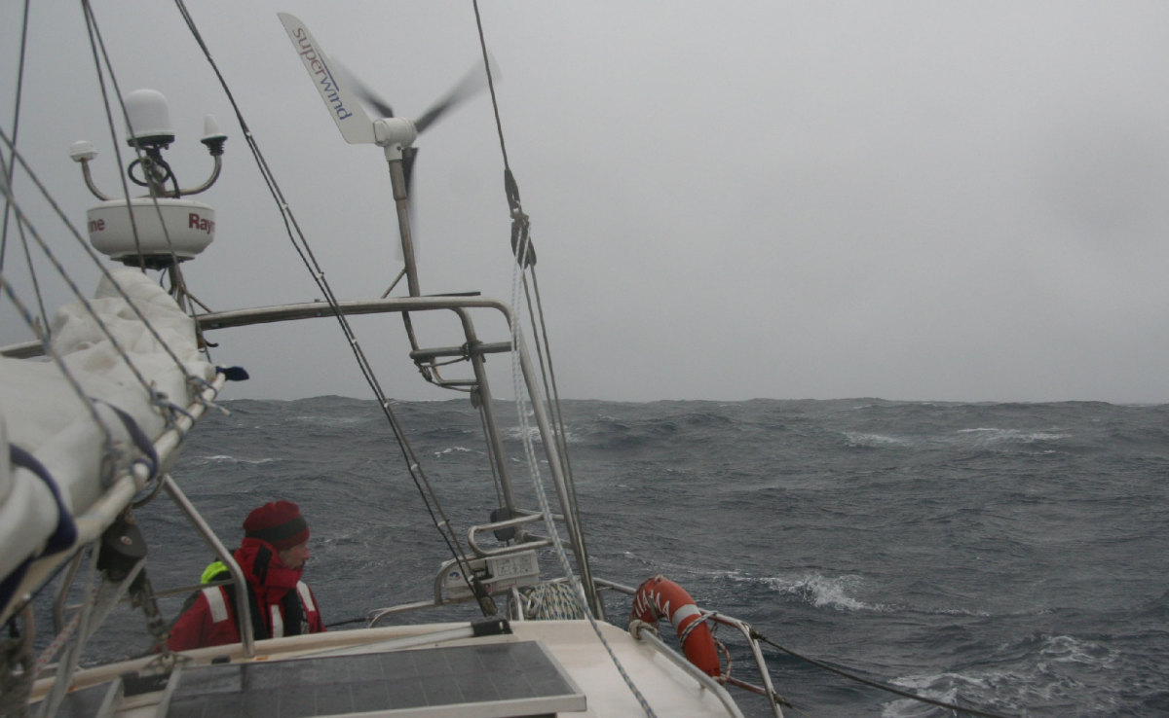
In brisk reaching conditions, wind generators pump out plenty of current
Photo courtesy of Superwind

Regulation matters
Getting the power from the turbine’s alternator and safely into your batteries sounds like the easy part of the process. However, not one of the main manufacturers uses the same terms or technology, and each is convinced the others’ claims are pure snake oil.
At one end of the spectrum is Marlec, a British company that manufactures the Rutland 914 and 1200 turbines. They use so-called Maximum Point Power Tracking (MPPT), which employs a DC-to-DC converter to constantly search for the voltage and current in the system that will optimize wattage (watts = volts X amps), an approach that has been shown to boost output from photovoltaics by as much as 30 percent. They also use a clever technology called Pulse Width Modulation (PWM) to reduce turbine speeds as the battery comes up to charge and needs less power. Simply put, PWM short-circuits the windings with increasingly long pulses, creating a growing braking force.
Sceptical of this, however, is Peter Anderson, a sailor who designed and built his own marine-specific turbine, marketed as the D400. “You cannot produce a structured output when you have a variable input as with a wind turbine,” he says of PWM technology. And after five years of development work with researchers in Delft, Holland, he concluded: “We were never able to demonstrate any increase in overall yield with MPPT, and if anything system performance was reduced.”
Klaus Krieger of Superwind, on the other hand, lies somewhere in the middle: “With a properly laid-out generator, optimized for low wind speeds, we do not see an advantage of MPPT regulation for small wind turbines. The advantage of generator efficiency, for the most part, is compensated by the loss of the MPPT electronics itself. However, a Pulse Width Modulation regulator allows us to charge the battery to 100 percent because it will provide the battery exactly the charging current it can accept at any stage of the charging process.”
Silentwind takes a similar view, although it still makes use of the DC-DC conversion element of MPPT technology in its turbine. “Our 12/24 volt generators start charging at wind speeds of less than 2m/s (4.2 knots) because the boost function of a DC/DC converter raises the output voltage in low wind conditions,” says Silentwind’s Stephanie Silva. “The Silentwind starts charging at 2 volts, providing a charge power of 3 to 5 watts.” The company claims this is an enormous advantage in protected anchorages, but while smart, it only yields tiny amounts of extra power.
Note that the PWM circuits in the Superwind and Silentwind have a small but important difference. While the Silentwind uses pulses to short the alternator and apply a variable braking effect, the Superwind diverts the pulses into a dump resistor, which burns off the excess power as heat, “so that the wind turbine is always electrically loaded” according to Krieger. Cleverly, the Superwind’s regulator also draws its power from the turbine, rather than from the battery, so no power means no current draw.
As for Primus Windpower’s turbines, they have a built-in charge controller that aims to maximize power coming out of the turbine. According to the head of sales Ken Kotalik, his company deliberately avoided MPPT or PWM technology because: “We like to keep it simple—reliability is key. Almost all of our turbines are coupled with solar panels, so the job of our units is bulk charging. Adding fancy electronics increases vulnerability and raises the price.”
An alternative to the external regulators that some of the manufacturers offer is a stand-alone “dump” type regulator, like that mentioned above. It can be added to any system and constantly monitors the power coming in from the turbine, as well as the state of charge of the batteries, diverting any excess into the resistor. It has the advantage of keeping the turbine at full load, where its blades are turning at their most efficient rpm.
Beware of relying on the turbine’s built-in “regulator” alone. This is usually a simple electronic brake triggered when the turbine is providing too much power and battery voltage rises too high. If your batteries are close to full charge, this will often result in an unsatisfactory stop-start routine. The battery voltage drops back as the wind generator brakes; then the regulator restarts the generator. This is far from the true regulation that your battery needs, carefully dialing back the amps as the battery comes up to full charge.
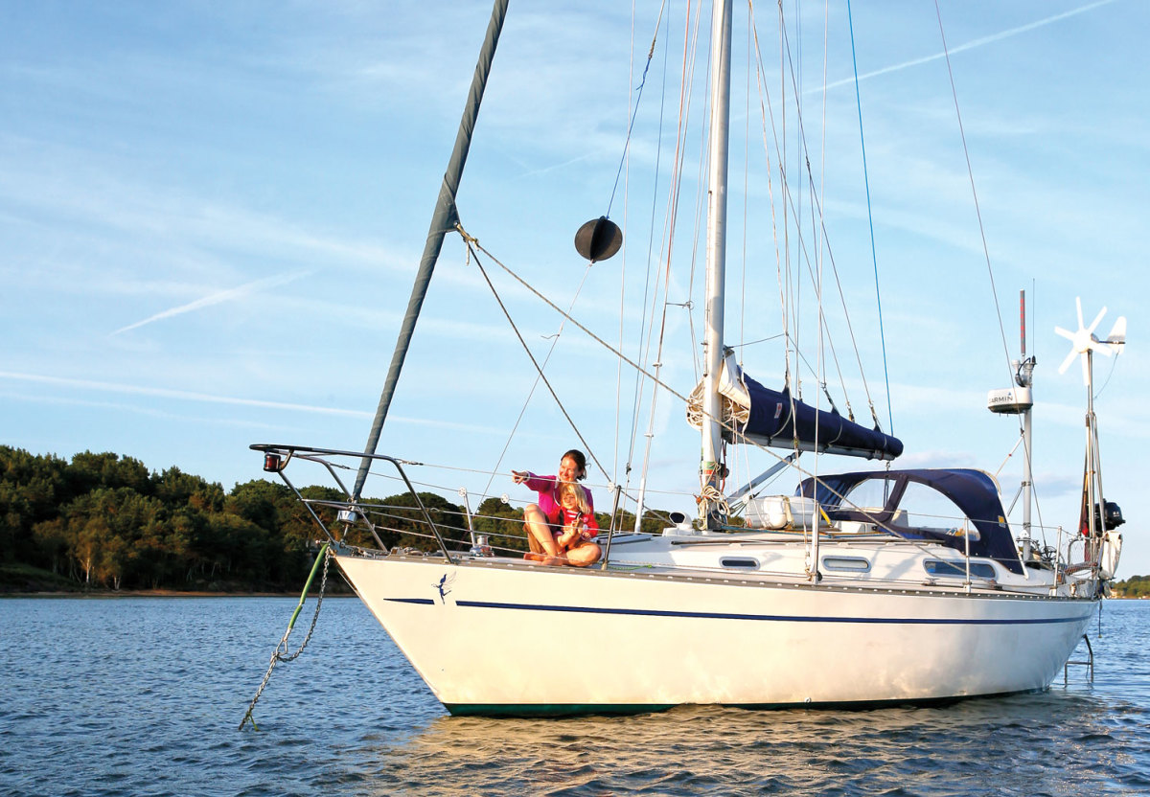
Any cruising boat can benefit from a wind generator

A question of aerodynamics
Turbine blades are another key area of differentiation between units, with some impressive claims. The blades operate on a similar principle to an aircraft wing, although there are some differences due to small scale. Unless they change pitch like the Superwind (more on this later), they are designed to produce optimum output at one given rpm only. If the turbine goes too fast, it loses efficiency (like a car in too high a gear); same if it rotates too slowly.
It is usually the blades that produce the noise and vibration associated with a turbine. Airflow becomes unstable at very high tip speeds, causing blades to flutter. There was a well-documented problem with the original Air-X from Primus Windpower, where the blades began to flutter at high speeds, creating a shriek that would drive other boats from an anchorage. The company has addressed this—first in the Air Breeze, with its wider blades, and later in the Air Silent-X, which uses an even quieter blue, carbon-fiber blades (made by Silentwind).
“Customers have noted an increase in power performance, especially in the lower wind speeds,” says Primus Windpower’s Paul Landino. “The precision carbon-fiber blue blades are balanced and therefore when installed have less of a tendency to create vibration again adding to the improvement of life on board.”
The “tip speed ratio” (TSR) of a turbine can be a helpful guide here. TSR describes how many times faster than the true wind speed the blade tips are moving. The original Air-X turbine, for instance, had a TSR of 16—so in a 20-knot wind, the tips would be moving at 320 knots. In only a modest gale, they’d approach the speed of sound. The D400, on the other hand, quotes a TSR of just 3.9, indicating that it is designed to rotate more slowly than the other turbines. It is heavily built, with more than 2lb of pure copper in its windings alone, but it has the advantage of its relatively low rpm.
Some turbine manufacturers quote a top “survival” speed for their machines, but this should be taken with a grain of salt as Peter Anderson at Eclectic, explains: “It is the turbulence level within a wind stream that is most damaging, and that is a variable you can neither predict nor easily quantify. We have had turbines run through sustained winds of 90-plus-knots with no damage. Equally, we have had tails torn off at a reported 55 knots.”
Unique among major manufacturers, Superwind has developed a mechanical approach to braking its systems. When in operation, it exploits the physics of rotation to alter the pitch of the blades mechanically, so that the faster they spin, the more the blades feather, slowing the turbine down again. Superwind says this system responds very quickly and can protect the system in the event of failure of the electronic braking.

How much power do you need?
When installing any generating equipment on the boat, it pays to do your sums first. Work out how much power you consume at anchor and underway in a kind of power “budget.” There are the obvious things, like fridges, plotters and interior lights. But remember navigation lights at night, watermakers, pumps and “invisible” consumers such as gas alarms, engine monitors, always-on entertainment systems. If you have hydraulics or electric winches on the boat, make sure you include a hefty margin in case of emergency. If you plan to use air conditioning, it’s unlikely that renewable power sources will be able to cover demand, so you’ll need to think about a diesel genset or fuel cell.
Then look at the type of sailing you’re planning to do: what is your average boat speed and do you expect to be doing plenty of upwind sailing, or are you sticking to tradewind routes? Finally, take account of any other generating capacity you have on board: solar, hydrogenerator and good old-fashioned engine power.
It is really worth putting the time in here, so you come out of this process with a clear and accurate idea of how much power you need to generate.

RESOURCES
Eclectic Energy eclectic
Marlec
Primus Windpower
Nature Power
Silentwind
Superwind November 2017

